Computer Language Coding Concepts

Inactive Clauses in a Command Reference in a Diagram
Inactive clauses in a command reference have been conceptually explained in the article Inactive Clauses in a Command Reference.

This article only illustrates how inactive clauses in a command reference look in a diagram.

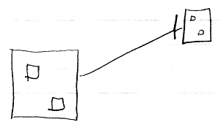

The large square on the left is a command reference. It is pointing out its target command definition with an object line, the solid line, targeting the square on the right, which is the command definition. The command reference on the left contains two inactive clauses, smaller squares, that do not redirect their target. The target definition on the right also shows the smaller squares inside of it. Both command reference and target definition both represent the same command object, so their contents are also the same, so they both show inactive clauses.

See also: Inactive Clauses in a Command Reference,
Creation Behavior of Command Calls in a Diagram

Author & Copyright: Jan-Joost van Zon Date: August 9, 2008 – August 9, 2008 Location: Oosterhout, The Netherlands Status: Finished

